

**Program :**B.tech(CSE)

**Specialization :**AIML

**Course Title :**AI Assisted Coding

**Course Code :**24CS002PC215

**Semester :**3rd semester

**Academic Session :**2025-2026

**Name of Student :**Challa Sravya

**Enrollment No. :**2403A52033

**Batch No. :**02

**Date :**16/09/2025

#LAB ASSIGNMENT

#TASK DESCRIPTION-1:

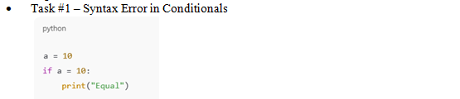

#PROMPT:

"Identify and correct the syntax error in this Python conditional statement:

CODE:

a = 10

if a = 10:

print('Equal')

Explain why the original code fails and how to fix it.

#QUESTION:

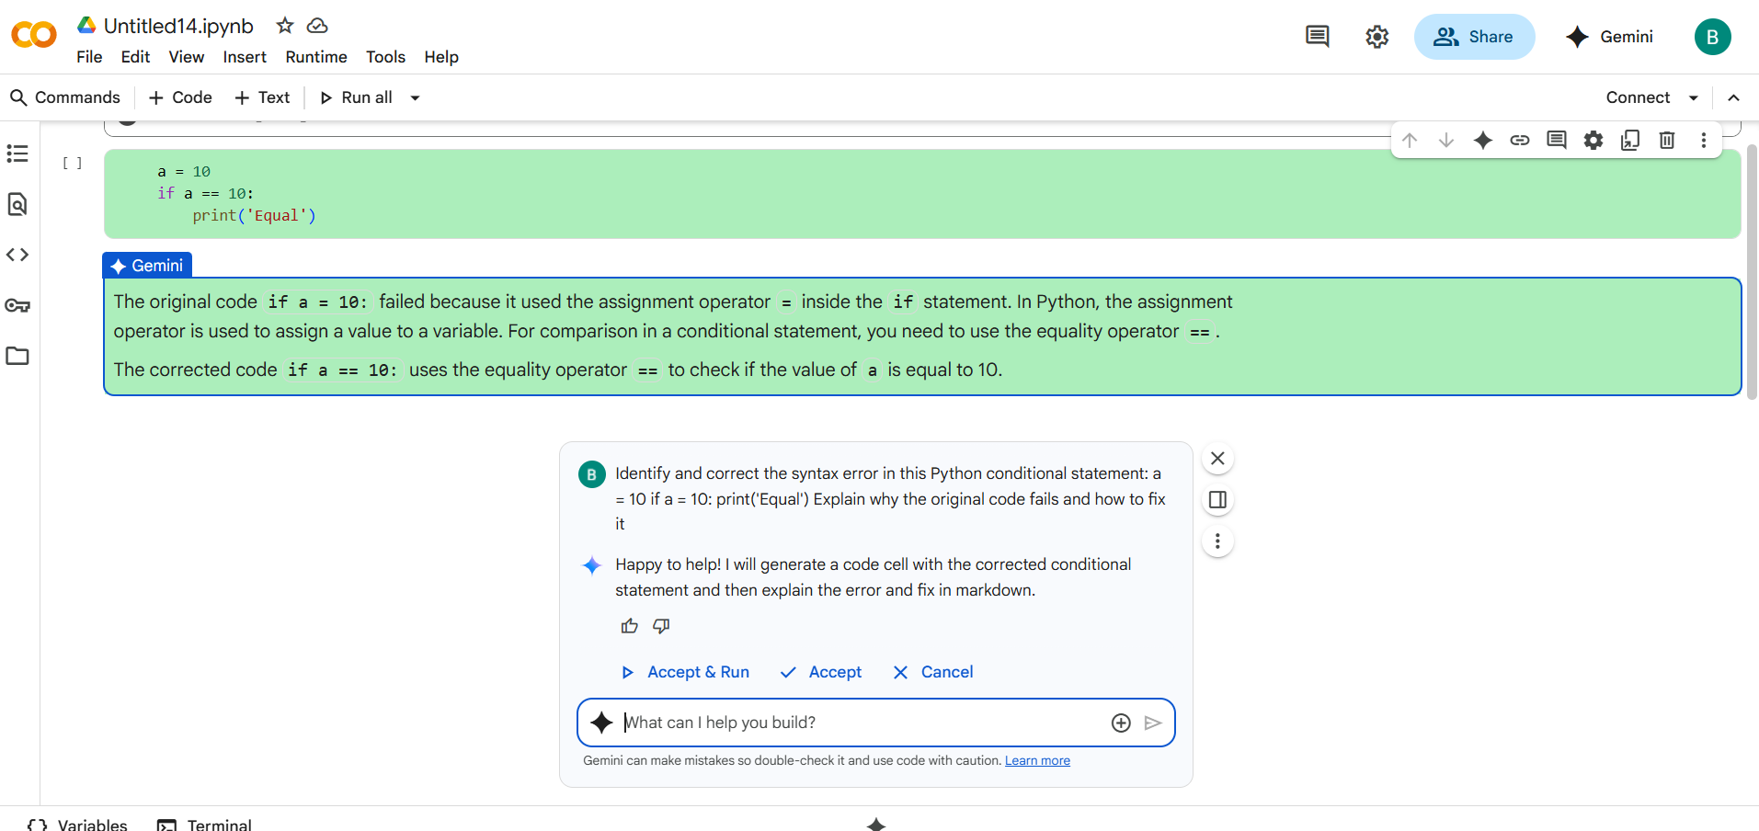

#CODE with OUTPUT:

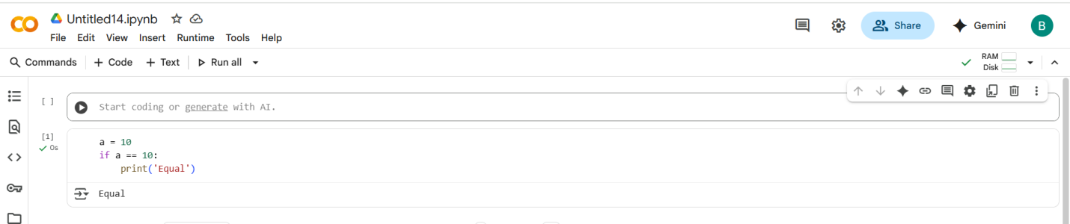

#EXPLANATION:

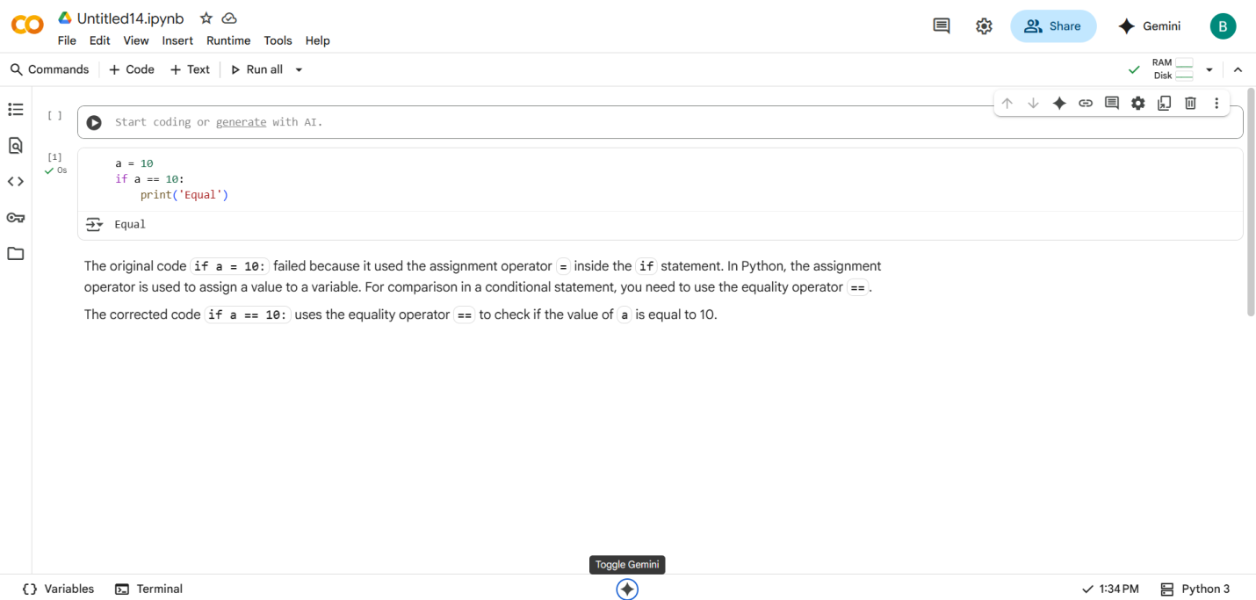#What I did:

I correct the error without using AI, After giving this code to AI it will also did same correction.

#TASK DESCRIPTION-2:

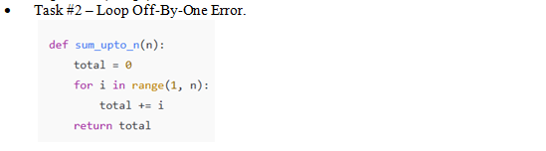

#PROMPT:

Fix the loop so that this function correctly returns the sum of numbers from 1 to n:

def sum_upto_n(n):

total = 0

for i in range(1, n):

total += i

return total

#QUESTION:

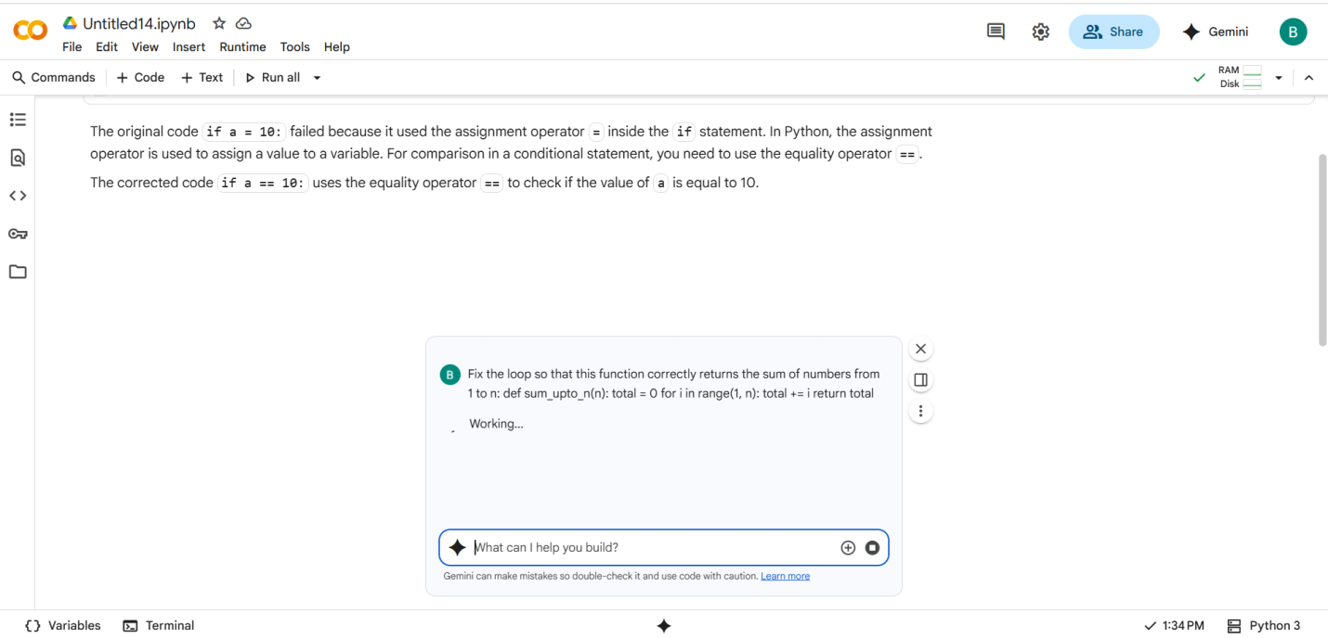

#CODE with OUTPUT:

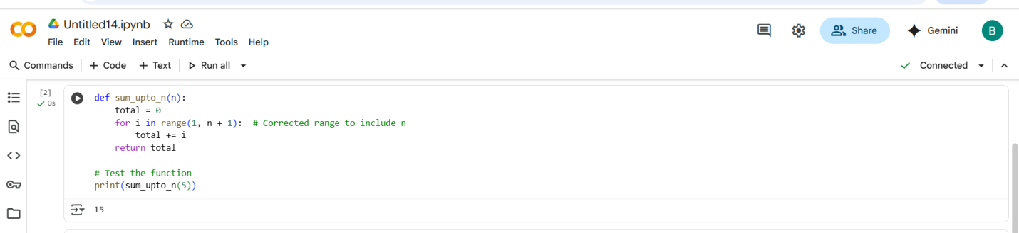

#EXPLANATION:

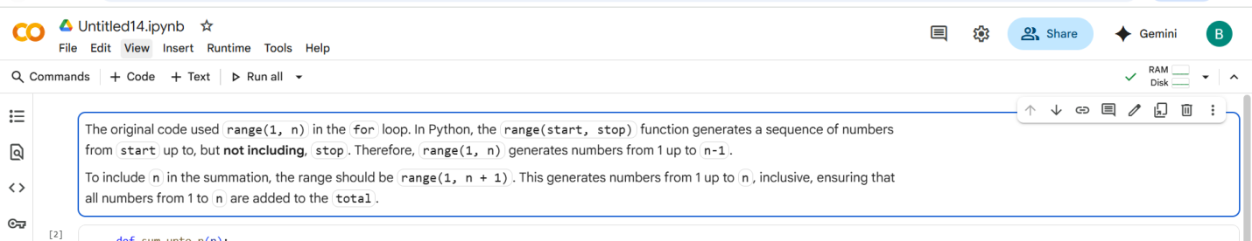

# What I did:

I correct this error in another way AI correction was different compare to me.

#TASK DESCRIPTION-3:

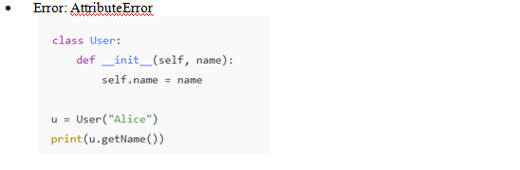

#PROMPT:

Fix the AttributeError in this Python code:

class User:

def __init__(self, name):

self.name = name

u = User("Alice")

print(u.getName())

The goal is to correctly print the user's name.

#QUESTION:

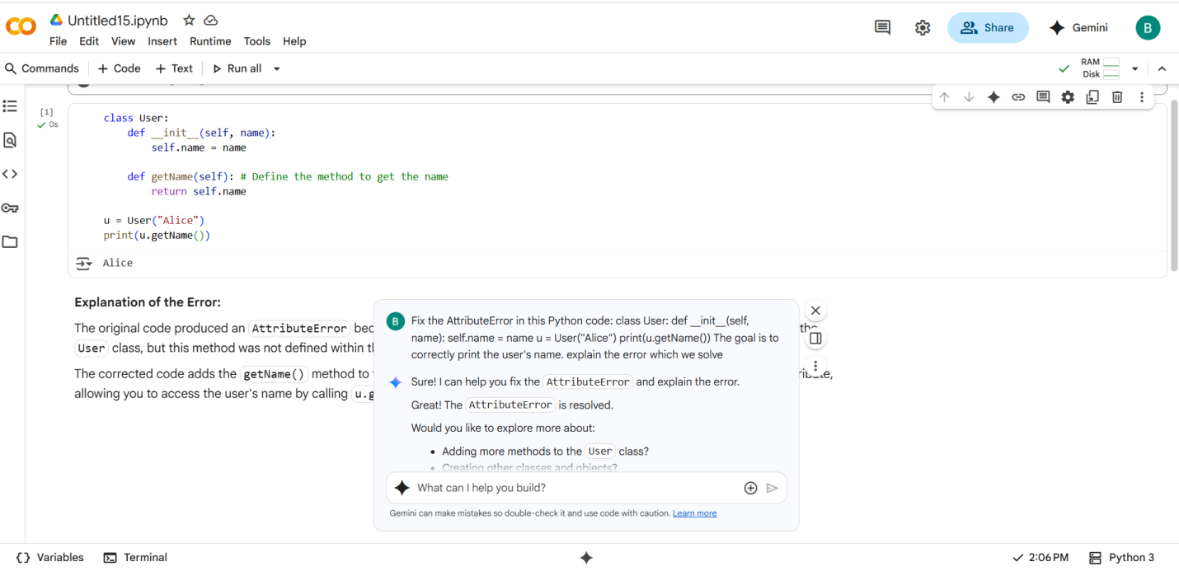

#CODE with OUTPUT:

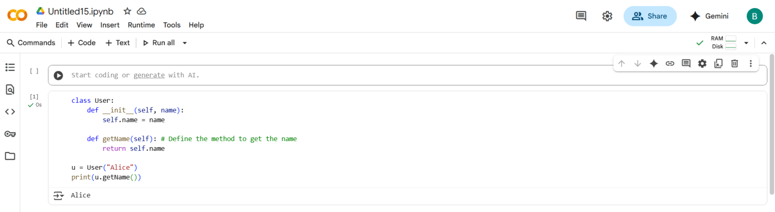

#EXPLANATION:

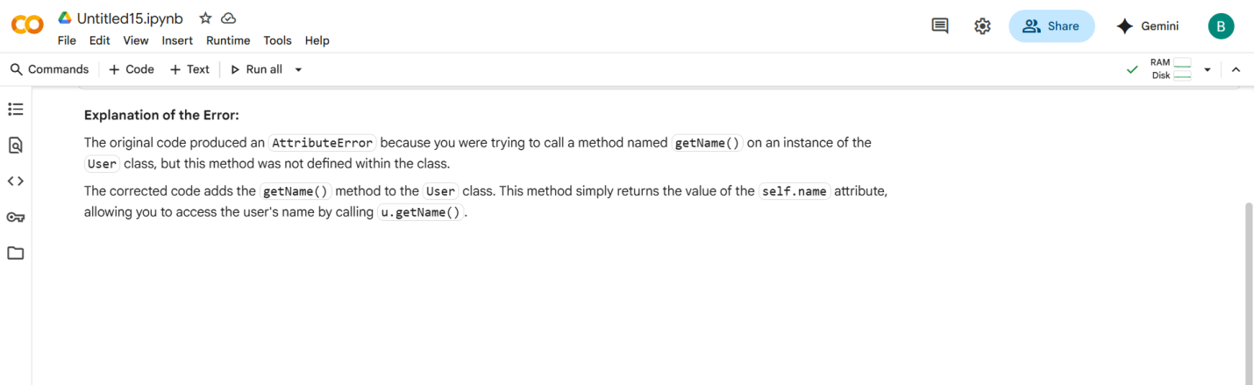

# What I did:

Actually I am facing littile bit of problem correction of this error finally I do almost correct code ,but AI did very well.

#TASK DESCRIPTION-4:

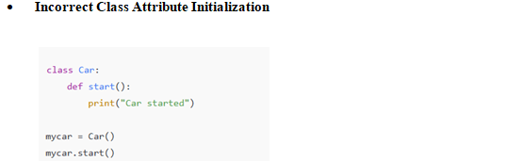

#PROMPT:

Fix the method definition so this Python class works correctly:

class Car:

def start():

print("Car started")

mycar = Car()

mycar.start()

The goal is to make sure the start() method runs without error when called on the object.

#QUESTION:

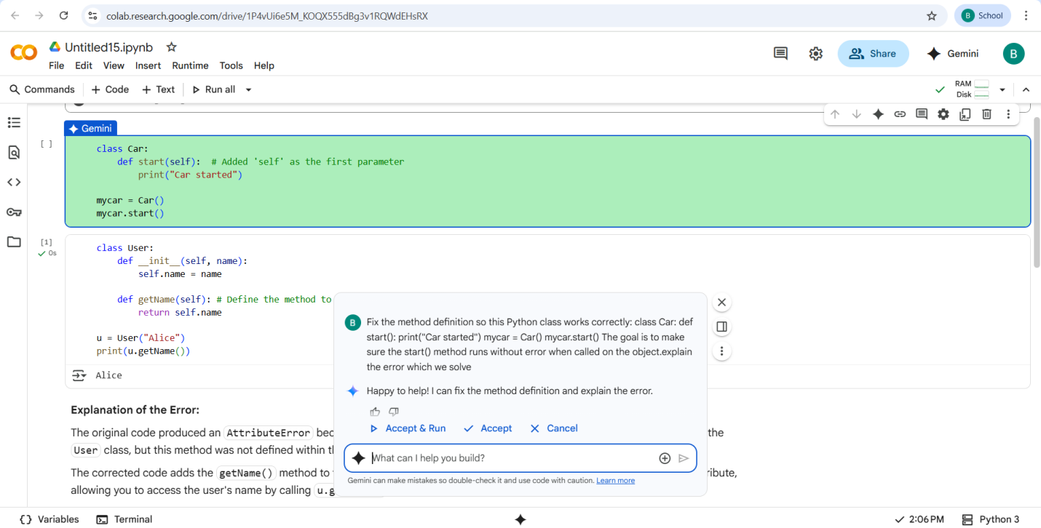

#CODE with OUTPUT:

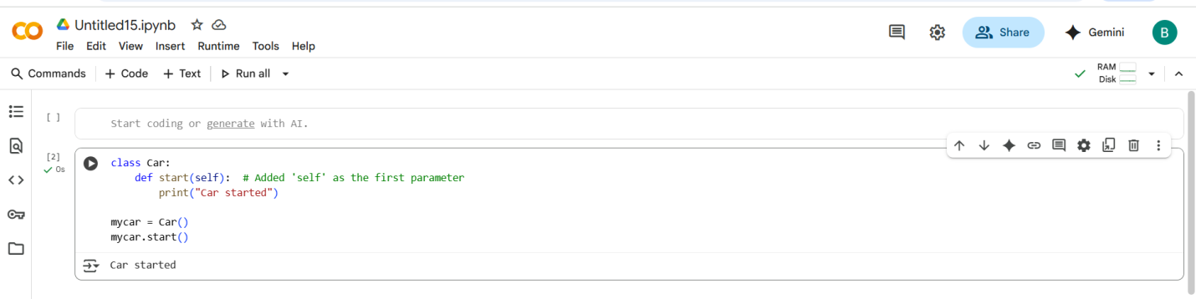

#EXPLANATION:

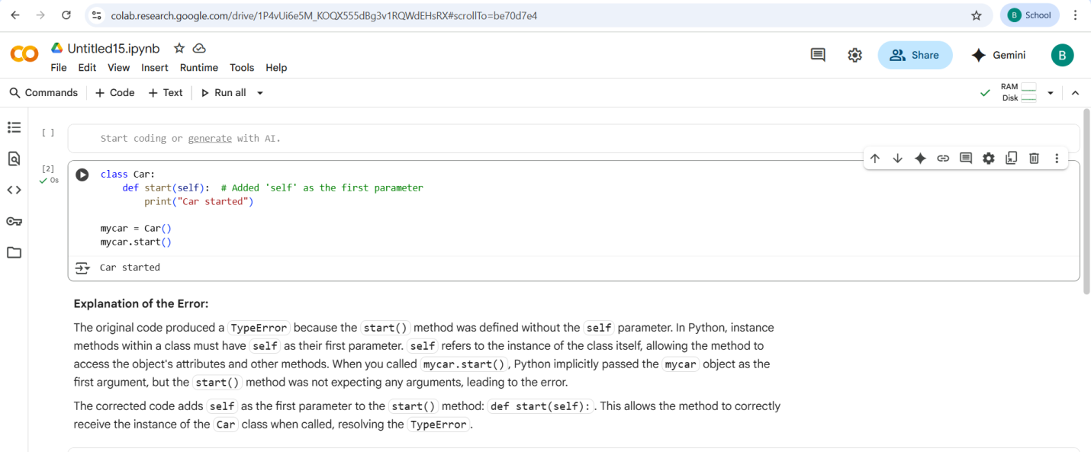

# What I did:

I correct this error without using AI , after giving this code to AI it will also do same thing.

#TASK DESCRIPTION-5:

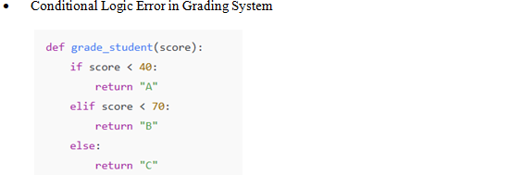

#PROMPT:

Fix the grading logic in this function so that it assigns correct letter grades based on score:

def grade_student(score):

if score < 40:

return "A"

elif score < 70:

return "B"

else:

return "C"

The goal is to make sure high scores get higher grades and low scores get lower grades.

#QUESTION:

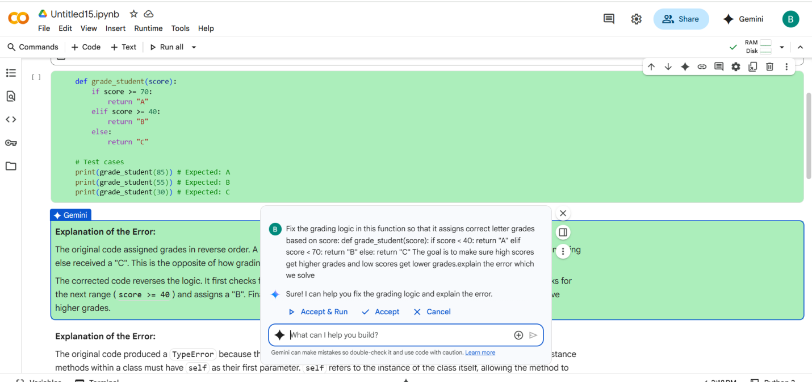

#CODE with OUTPUT:

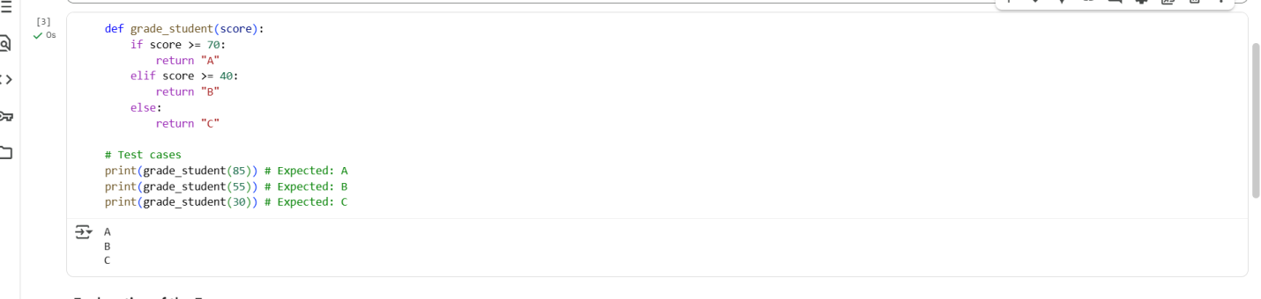

#EXPLANATION:

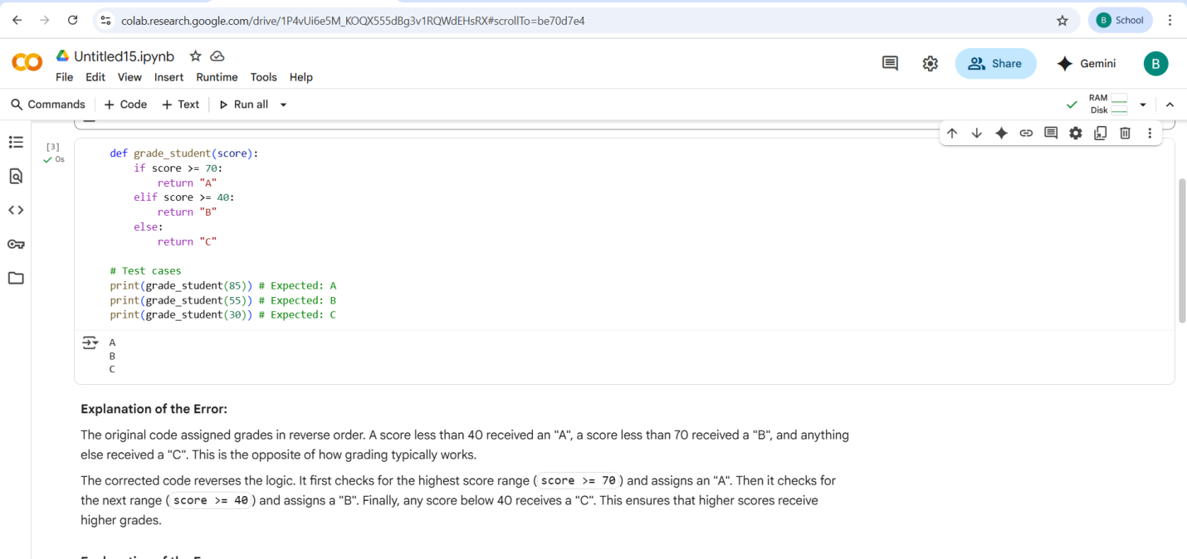

# What I did:

I corrected this error without using the AI , after giving to AI some differences compare to AI code and My code.

- THANK YOU-